Q-learning with Look-up Table and Recurrent Neural Networks as a Controller for the Inverted Pendulum Problem

ABSTRACT
In reinforcement learning, Q-learning can discover the optimal policy. This paper discusses the inverted pendulum problem using Q-learning as controller agent. Two methods for Q-learning are discussed here. One is look-up table, and the other is approximation with recurrent neural networks.

- INTRODUCTION
Q-learning is an incremental dynamic programming procedure that determines the optimal policy in a step-by-step manner. It is an on-line procedure for learning the optimal policy through experience gained solely on the basis of samples of the form:
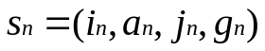 (1.1)
where n denotes discrete time, and each sample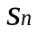 consists of a four-tuple described by a trial action a_{n} on state in that results in a transition to state j_{n}=i_{n+1} (i_{n} denote state at time n) at a cost 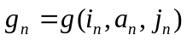. And it is highly suited for solving Markovian decision problems without explicit knowledge of the transition probabilities. The requirement of using Q-learning successfully is based on the assumption that the state of the environment is fully observable, which in turn means that the environment is a fully observable Markov chain. However, if the state of the environment is partially observable, for example : the sensor device on the inverted pendulum may be imprecise, special methods are required for discovering the optimal policy. To overcome this problem, a utilization of recurrent neural networks combined with Q-learning as a learning agent had been proposed.
According to Bellman’s optimality criterion combined with value iteration algorithm, the small step-size version formula of Q-learning is described by
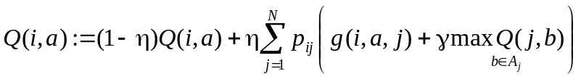 for all (i,a) (1.2)
where η is a small learning-rate parameter that lies in the range 0<η<1. And the other symbols are defined as : “ i ” is sate at time n; “ j “ is state at time n+1; “a” is the action been taken at time n; “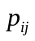” is the transition probability defined as 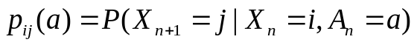; “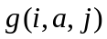” is the cost as i, a, j are defined previously; “γ” is discount factor. By adjustingγ we are able to control the extent to which the learning system is concerned with long-term versus short-term consequences of its own actions. In the limit, when γ= 0 the system is myopic in the sense that it is only concerned with immediate consequences of its action. Asγ approaches 1, future costs become more important in determining optimal actions. Therefore we usually confine the discount factor 0<γ<1.
We may eliminate the need for this prior knowledge by formulating a stochastic version of Eq.(1.2) . Specifically, the averaging performed in an iteration of Eq. (12.37) over all possible states is replaced by a single sample, there by resulting in the following update for the Q-factor:
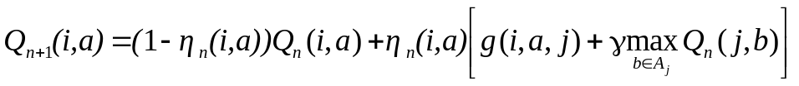 (1.3)
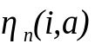 is the learning rate parameter at time step n for the state-action pair (i,a).

- THE INVERTED PEDULUM PROBLEM
The inverted pendulum problem consists of a pole that is freely hinged on top of a wheeled cart, which can move on a one dimensional track of fixed length (Fig.1). The goal is to apply a fixed magnitude force to one side of the cart to accelerate it at each time step, so as to keep the pole always upright and within a fixed angle from the vertical, and to keep the cart away from the ends of the track.
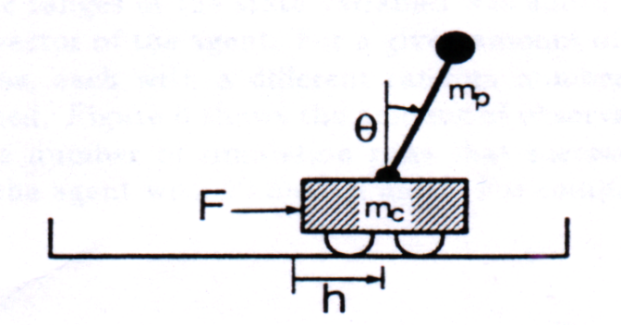
Figure 1 : Inverted pendulum problem.
  - Dynamics of the Problem
The target system is characterized by four variables; the angle of the pole and its angular velocity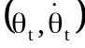 , and the horizontal position and velocity of the cart 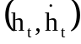. The equations governing the behavior of the system are given below:
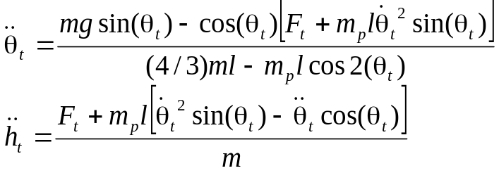 (2.1) (2.2)
where (1.1kg) is the mass of the cart plus the pole, is the gravity acceleration constant (9.8m/s²), is half the length of the pole(0.5m), 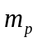 is the mass of the pole(0.1kg) , 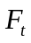 is the output of the agent (+10N or –10N), 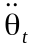 denotes angular acceleration, 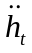 denotes horizontal acceleration. The pole must be kept within 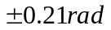 from vertical, and the cart must be kept within 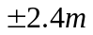 from the center of the track. This system is simulated numerically by Euler method with a sampling period of =0.02s. The angular and horizontal velocity formula are given below:
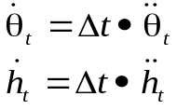 (2.2)
The angel and the horizon offset is updated according to :
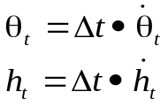 (2.3)

3 Q-LEARNING WITH LOOK-UP TABLE METHOD
This method is to build a table for saving Q-factor. It is suitable for small size problems. In this problem, the storage size depends on the state and the action amounts. The action size is just two : push left and push right. And we define the cart-pole system in to 162 states :

Cart position | -2.4 ~ -0.8 | -0.8 ~ 0.8 | 0.8 ~ 2.4
State | 1 | 2 | 3

Velocity of cart | <-0.5 | -0.5 ~ 0.5 | >0.5
State | 1 | 2 | 3

Pole angle | <-6 | -6 ~ -1 | -1 ~ 0 | 0 ~ 1 | 1 ~ 6 | >6
State | 1 | 2 | 3 | 4 | 5 | 6

Angle velocity of the pole | <-50 | -50 ~ 50 | >50
State | 1 | 2 | 3
Table 1. each variable’s state definition

Therefore, there are 3*3*6*3=162 states. The Q-factor table is somewhat like:

State | Action: push left | Action: push right
1 | -0.011231 | -0.2533
2 | -0.00655 | -0.0354
* | * | *
162 | -0.20015 | -0.005014
Table 2. Q-factor table

3.1 Learning procedure for this method
Algorithm:

1.Set Q-factor table all entries zero.
2.Initial cart and pole.
3.Get current state.
4.Determine a action according to equation : 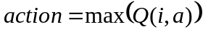.
(action= { left, right} )
5.Push cart and get current state.
6.if fail, reinforcement = -1 and reset cart. Else reinforcement = 0.
7.Update Q according to equation :
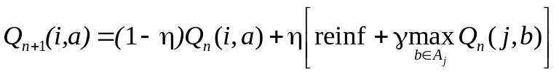 (3.1)
8.Repeat 3-7, until the agent learns it.

The agent receive reinforcement from the world, and return an action to the world round and round as shown below:
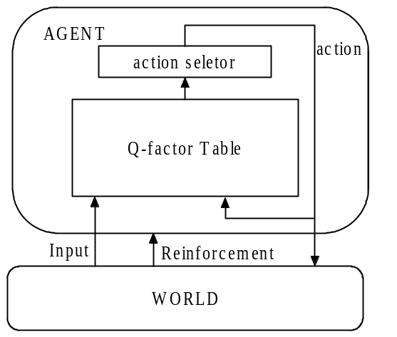
Fig 2. Structure of the learning agent

- SIMULATION
A test was considered successful if the agent could balance the pole for 1000000 successive iterations (about 5.56 hours in real time).

  - Simulation with Fixed Restart
The inverted pendulum task was simulated with the agent described before having the following parameters: learning rate η=0.2, discount factor γ=0.85. In the initial test, fixed restarts were used after the pole fell over. In this case, the agent took around 186 trials to succeed in the task (Fig.3).
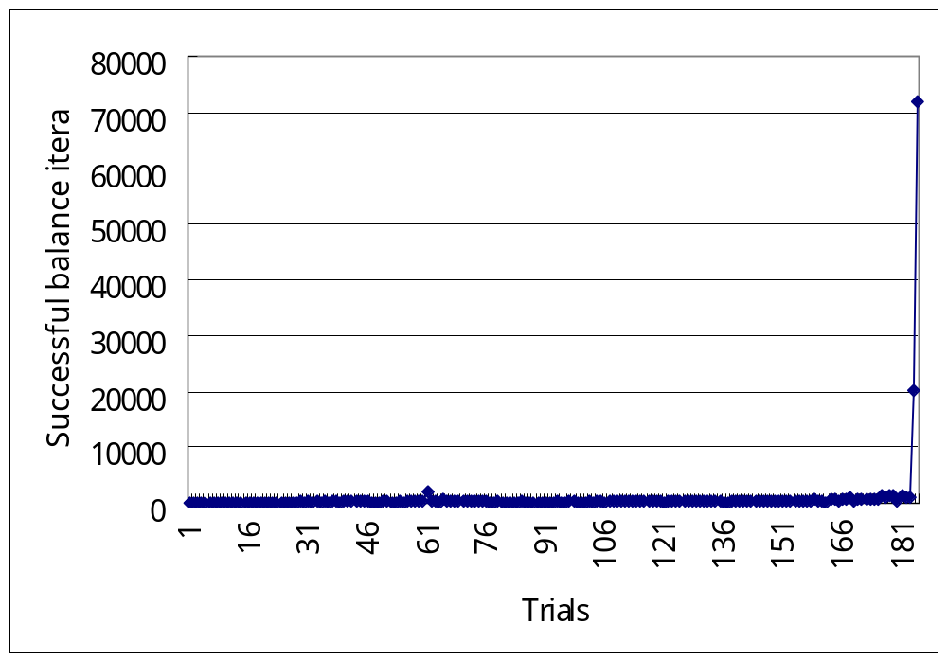
Fig 3. Learning profile for fixed restart
Here set the restarts at 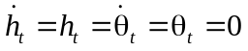. The learning parameter η and discount factor γ are important factors for the agent to learn. In fact it is very hard to find the combination of η and γ so that the agent can learn to control the cart successfully. Most of it would stop making progress at 100~800 iterations. It needs some luck to succeed.

  - . Simulation with Random Restart
To enhance exploration, random restarts were used. The result is shown in Fig.4. In this case, the agent took around 146 trials to succeed in the task, with the parameters: learning rate η=0.5, discount factor γ=0.85.

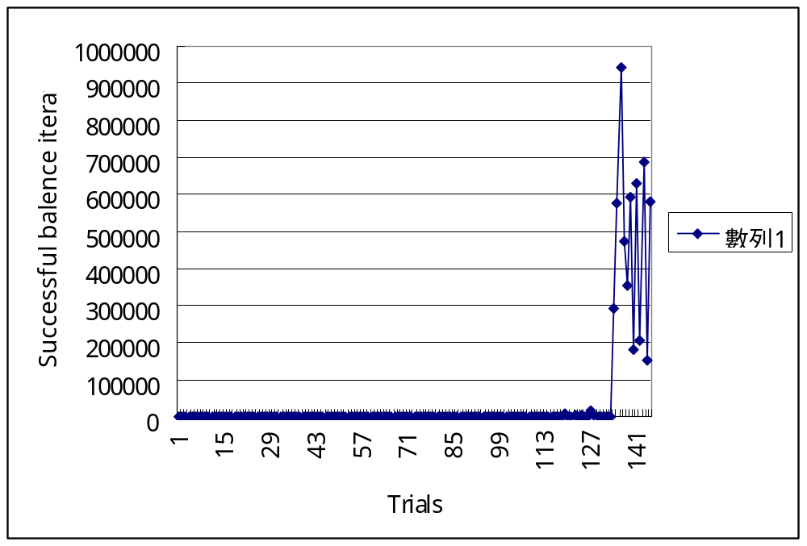
Fig.4. Learning profile for random restart

Here set the restarts at 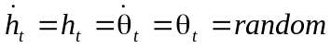, where –0.01<random<0.01. Random restart enhances exploration so that the agent will become much easier to be trained. And it is clearly that it needs less time to learn successfully. Below list possible combinations of learning parameter η and discount factor γ:

η γ | 0.1 | 0.2 | 0.3 | 0.4 | 0.5 | 0.6 | 0.7 | 0.8 | 0.9
0.1 |  |  |  |  |  | 870 | 198
0.2 |  |  |  |  |  | 352 | 6831 | 53 | 541
0.3 |  |  |  |  |  |  | 155 | 231 | 3225
0.4 |  |  |  |  |  |  |  | 283 | 1288
0.5 |  |  |  |  |  |  | 1383 |  | 590
0.6
0.7 |  |  |  |  |  |  |  | 120
0.8
0.9
Table 3. The trials needed for learning successfully
We can see the learning rate should be less than 0.5, and the discount factor should be lager than 0.5
The trajectory of the behavior of the agent after learning shows how the agent control the cart so that the pole is balanced at –0.21<angle<0.21 and the cart is restrained between –2.4m<position<2.4m.
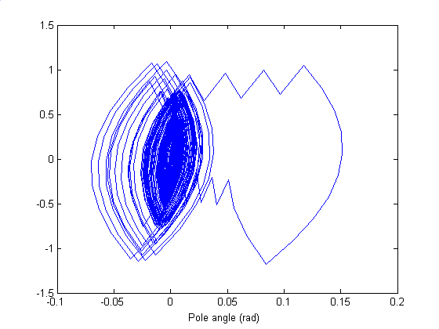
Pole angular velocity (rad/s)
Fig 5. Trajectory of the Pole angle – Pole angle velocity

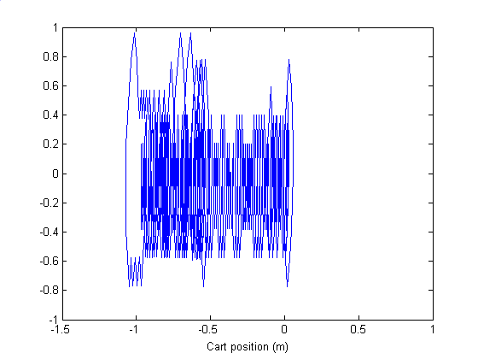
Cart velocity (m/s)

Fig 6. Trajectory of the Cart position – Cart velocity
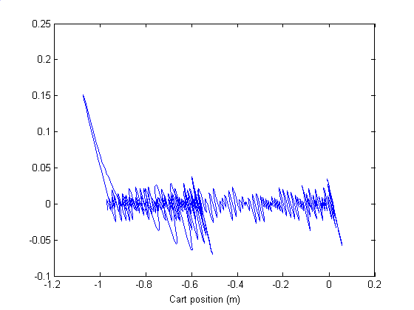
Pole angle (radz)

Fig 7. Trajectory of the Cart position – pole angle
- Q-LEARNING FOR RECURRENT NEURAL NETWORKS
Although look-up table method is easy to implement, it needs large space for storing Q-factor. This paper discusses another way to store Q-factor, which is to use recurrent neural networks for getting Q-factor.

  - Structure of the Learning Agent
The learning agent’s main part is a recurrent neural network of the type which can produce outputs from its inputs immediately. The network is trained to output Q-values for the current input and the current internal state of the recurrent neural network. The output units of the network have a linear activation function to be able to produce Q-values of arbitrary magnitude. For the hidden units, the sigmoid function is used.
One of the output s of the network is selected by the equation:
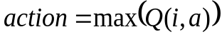 (5.1)
if 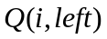>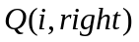, push left. Else push right. The action selected is also fed back into the neural network through a one step time delay (a_{t-1}), as well as the current input from the environment y_{t} , and the internal feedback.
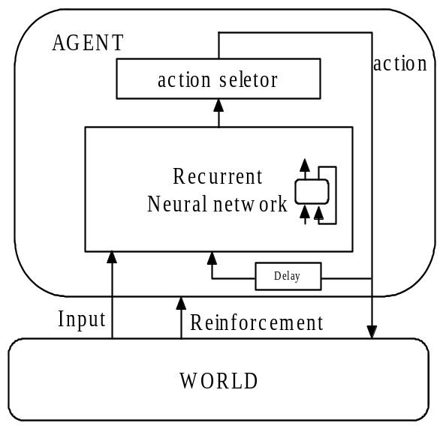
Fig 8. Structure of the learning agent of recurrent neural network

5.2. Learning procedure for this method

Algorithm:
1.Initialize the neural network.
2.Initial cart and pole.
- Get current state.
- Obtain 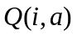 for each action by substituting current state and action into the neural network.
5.Determine a action according to equation : 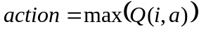.
(action= { left, right} )
6.Push cart and get current state.
7.if fail, reinforcement = -1 and reset cart. Else reinforcement = 0.
8.Generate 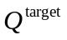 according to equation :
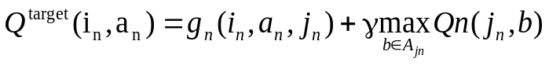 (5.2)
use to train the network as Fig9. shown.
8.Repeat 3-7, until the agent learns it.

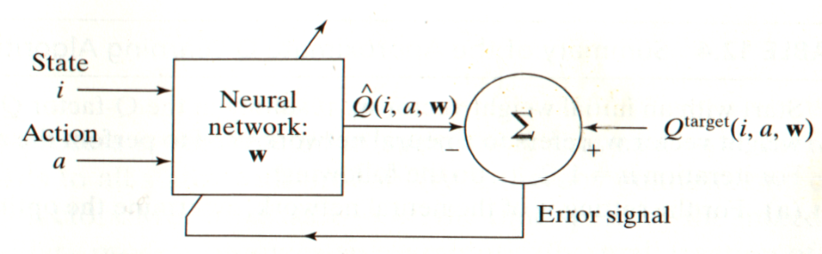
Fig 9. Neural network layout for approximating the target Q-factor

  - Recurrent Neural Network Architecture, and Learning Algorithm
Here we use Elman network, which is similar to a three layer feed forward neural network, but it has feedback from the hidden unit outputs, back to its input.
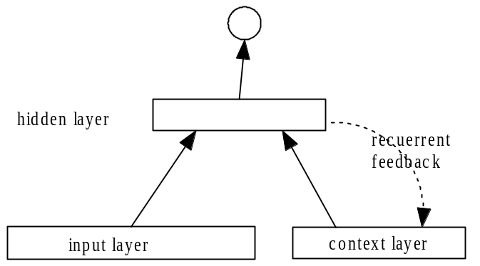
Fig 10. Elman network which activations are copied from hidden layer to context layer on a one-for-one basis, with fixed weight of 1.0. Solid lines represent trainable connections.

Here use 14 neurons in hidden layer, and 1 neuron in output unit, and 163 neurons in input layer, which 162 neurons for 162 states and 1 neuron for action. The output units of the network have a linear activation function to be able to produce Q-values of arbitrary magnitude. For the hidden units, the sigmoid function is used. In this study, we used the error back propagation algorithm to train Elman network. BP does not treat the recurrent connections properly, but require little computation.

- SIMULATION
I have to say sorry about the implementation of Q-learning for Elman network. Many ways are tried but failed to solve it. The best record of the agent is to keep the pole in 88 seconds. Probably the learning rate η and discount factor γ are critical to the learning procedure, but I cannot find good value of them.
But if we use loop-up table training result to train the neural network, the neural network can learn it.

- SPACE REQUIREMENT (LOOK-UP TABLE VERSUS ELMAN NETWORK)

Neural network:
Number of inputs : 163
Number of hidden neurons : 14
Number of context neurons :14
Number of output neurons : 1
Number of biases : 14+1=15
Total number of synaptic weights and biases =
(163+14)*14 + 14*1 + 15 + 1 = 2058.

Look-up table:
Number of states : 162
Number of actions : 2
Size of table = 162*2 = 324

Although neural network method needs more space than look-up table in this problem, in large size problem it will require less space than look-up table.

References
[1] Ahmet Onat, “Q-learning with recurrent Neural Networks as a Controller for the Inverted Pendulum Problem”, The Fifth International Conference on Neural Information Processing, pp 837-840, October 21-23, 1998.
[2] Simon Haykin, “Neural Networks .second edition”, pp 603-631, 1998.
[3] Jeffrey L. Elman , “ Finding Structure in Time”, Cognitive Science 14, 179-211, pp 179-211, 1990.

Attachments:
- Q-learning with Look-up Table in C code … Qlearning_table.cpp
- Q-learning with Elman network in C code … Qlearning_elman.cpp
- Demo of Q-learning with Look-up Table in matlab code … Q_learning_demo folder, see disk.

1.Q-learning with Look-up Table in C code … Qlearning_table.cpp
#include <stdio.h>
#include <stdlib.h>
#include <math.h>
#include <process.h>

#define GRAVITY 9.8
#define MASSCART 1.0
#define MASSPOLE 0.1
#define TOTAL_MASS (MASSPOLE + MASSCART)
#define LENGTH 0.5 /* actually half the pole's length */
#define POLEMASS_LENGTH (MASSPOLE * LENGTH)
#define FORCE_MAG 10.0
#define TAU 0.02 /* seconds between state updates */
#define FOURTHIRDS 1.3333333333333
#define sqr(x) ( (x) * (x) )
#define W_INIT 0.0
#define NUM_BOXES 162
static int RND_SEED = 8800;
static double ALPHA = 0.5; /* learning rate parameter */
static double BETA = 0.01; /* magnitude of noise added to choice */
static double GAMMA = 0.85; /* discount factor for future reinf */
static double q_val[NUM_BOXES][2]; /* state-action values */
static first_time = 1;
static int cur_action, prev_action;
static int cur_state, prev_state;

int get_action(double,double,double,double,double);
void cart_pole(int,double*,double*,double*,double*);
double rnd(double, double);
int get_box(double, double, double, double); /*state*/
void reset_controller(void); /* reset state/action before new trial */

void main()
{
int action,box,i;
long success,trial;
double x, x_dot, theta, theta_dot,reinf,predicted_value;
FILE *fptr;
fptr=fopen("rand_restart.txt","w");
x=x_dot=theta=theta_dot=rnd(-BETA,BETA);

success=0;
trial=1;
reinf=0.0;
while (success<1000000) /* If the pole doesn't fall during 1-million trials,assume it succcess.*/
{
action=get_action(x,x_dot,theta,theta_dot,reinf);
cart_pole(action,&x,&x_dot,&theta,&theta_dot);
box=get_box(x,x_dot,theta,theta_dot);
if (box==-1)
{ reinf=-1.0;
predicted_value = 0.0;
q_val[prev_state][prev_action]
+= ALPHA * (reinf + GAMMA * predicted_value - q_val[prev_state][prev_action]);
reset_controller();
x=x_dot=theta=theta_dot=rnd(-BETA,BETA);
trial++;
printf("At %d success ,try %d trials\n",success,trial);
fprintf(fptr,"%d\t%d\n",trial,success);
success=0;
}else{
success++;
reinf=0.0;
}
}
printf("Success at %d trials \n",trial);
for (i=0;i<NUM_BOXES;i++)
fprintf(fptr,"%g %g\n",q_val[i][0],q_val[i][1]);
fclose(fptr);

}

/*----------------------------------------------------------------------
cart_pole: Takes an action (0 or 1) and the current values of the
four state variables and updates their values by estimating the state
TAU seconds later.
----------------------------------------------------------------------*/

void cart_pole(int action,double *x,double *x_dot,double *theta,double *theta_dot)
{
double xacc,thetaacc,force,costheta,sintheta,temp;

force = (action>0)? FORCE_MAG : -FORCE_MAG;
costheta = cos(*theta);
sintheta = sin(*theta);

temp = (force + POLEMASS_LENGTH * *theta_dot * *theta_dot * sintheta)
/ TOTAL_MASS;

thetaacc = (GRAVITY * sintheta - costheta* temp)
/ (LENGTH * (FOURTHIRDS - MASSPOLE * costheta * costheta
/ TOTAL_MASS));

xacc = temp - POLEMASS_LENGTH * thetaacc* costheta / TOTAL_MASS;

/*** Update the four state variables, using Euler's method. ***/

*x += TAU * *x_dot;
*x_dot += TAU * xacc;
*theta += TAU * *theta_dot;
*theta_dot += TAU * thetaacc;
}

/*** Q-learning part ***/
/*----------------------------------------------------------------------------+
| get_action : returns either 0 or 1 as action choice; |
| accepts five "black box" inputs, the first four of which are |
| system variables, and the last is a reinforcement signal. |
| Note that reinf is the result of the previous state and |
| action. |
+----------------------------------------------------------------------------*/

int get_action(double x, /* system variables == state information */
double x_dot,
double theta,
double theta_dot,
double reinf) /* reinforcement signal */
{
int i,j;
double predicted_value; /* max_{b} Q(t, ss, b) */
if (first_time) {
first_time = 0;
reset_controller(); /* set state and action to null values */

for (i = 0; i < NUM_BOXES; i++)
for (j = 0; j < 2; j++)
q_val[i][j] = W_INIT;

printf("... setting learning parameter ALPHA to %.4f.\n", ALPHA);
printf("... setting noise parameter BETA to %.4f.\n", BETA);
printf("... setting discount parameter GAMMA to %.4f.\n", GAMMA);
printf("... random RND_SEED is %d.\n", RND_SEED);
srand(RND_SEED); /* initialize random number generator */
}

prev_state = cur_state;
prev_action = cur_action;
cur_state = get_box(x, x_dot, theta, theta_dot);

if (prev_action != -1) /* Update, but not for first action in trial */
{
if (cur_state == -1)
/* failure state has Q-value of 0, since the value won't be updated */
predicted_value = 0.0;
else if (q_val[cur_state][0] <= q_val[cur_state][1])
predicted_value = q_val[cur_state][1];
else
predicted_value = q_val[cur_state][0];

q_val[prev_state][prev_action]
+= ALPHA * (reinf + GAMMA * predicted_value
- q_val[prev_state][prev_action]);
}

/* Now determine best action */
if (q_val[cur_state][0] + rnd(-BETA, BETA) <= q_val[cur_state][1])
cur_action = 1;
else
cur_action = 0;

return cur_action;
}

double rnd(double low_bound, double hi_bound)
/* rnd scales the output of the system random function to the
* range [low_bound, hi_bound].
*/
{
double highest = 99999;
return (rand() / highest) * (hi_bound - low_bound) + low_bound;
}

void reset_controller(void)
{
cur_state = prev_state = 0;
cur_action = prev_action = -1; /* "null" action value */
}

/* The following routine was written by Rich Sutton and Chuck Anderson,
with translation from FORTRAN to C by Claude Sammut */

/*----------------------------------------------------------------------
get_box: Given the current state, returns a number from 0 to 161
designating the region of the state space encompassing the current state.
Returns a value of -1 if a failure state is encountered.
----------------------------------------------------------------------*/

#define one_degree 0.0174532 /* 2pi/360 */
#define six_degrees 0.1047192
#define twelve_degrees 0.2094384
#define fifty_degrees 0.87266

int get_box(double x, double x_dot, double theta, double theta_dot)
{
int box=0;

if (x < -2.4 ||
x > 2.4 ||
theta < -twelve_degrees ||
theta > twelve_degrees) return(-1); /* to signal failure */

if (x < -0.8) box = 0;
else if (x < 0.8) box = 1;
else box = 2;

if (x_dot < -0.5) ;
else if (x_dot < 0.5) box += 3;
else box += 6;

if (theta < -six_degrees) ;
else if (theta < -one_degree) box += 9;
else if (theta < 0) box += 18;
else if (theta < one_degree) box += 27;
else if (theta < six_degrees) box += 36;
else box += 45;

if (theta_dot < -fifty_degrees) ;
else if (theta_dot < fifty_degrees) box += 54;
else box += 108;

return(box);
}

- Q-learning with Elman network in C code … Qlearning_elman.cpp
#include <stdio.h>
#include <stdlib.h>
#include <math.h>
#include <process.h>
#include <conio.h>
#include <time.h>

#define GRAVITY 9.8
#define MASSCART 1.0
#define MASSPOLE 0.1
#define TOTAL_MASS (MASSPOLE + MASSCART)
#define LENGTH 0.5 /* actually half the pole's length */
#define POLEMASS_LENGTH (MASSPOLE * LENGTH)
#define FORCE_MAG 10.0
#define TAU 0.02 /* seconds between state updates */
#define FOURTHIRDS 1.3333333333333
#define sqr(x) ( (x) * (x) )

static double ALPHA = 0.05; /* learning rate parameter */
static double BETA = 0.01; /* magnitude of noise added to choice */
static double GAMMA = 0.8; /* discount factor for future reinf */

static double q_left, q_right; /* state-action values */
static first_time = 1;
static int cur_action, prev_action;
static int cur_state, prev_state;
static double x, x_dot, theta, theta_dot,reinf,predicted_value;
/* Define network variables */
#define L2 14
#define L1 (10+L2) /* 9 neurons for state, one for action */
static double W1[L2][L1], W2[L2], B1[L2], B2, Y1[L2], Y2 ,X[L1];

int get_action(double,double,double,double,double);
void cart_pole(int,double*,double*,double*,double*);
double rnd(double, double);
int get_box(double, double, double, double); /*state*/
void reset_controller(void); /* reset state/action before new trial */
double elman(int state,int action);
void BP(int state,int action,double reinf);
double sigmod(double x);
void initial_network(void);
double maxium(double,double);

long best=0;

void main()
{
int action,box,i,j,c=0;
long success,trial,count;
FILE *fptr;
srand((unsigned)time(NULL)); /* initialize random number generator */
initial_network();
x=x_dot=theta=theta_dot=rnd(-BETA,BETA);
reset_controller();
success=0;
count=0;
trial=1;
reinf=0.0;
while (success<1000000) /* If the pole doesn't fall during 1-million trials,assume it succcess.*/
{
action=get_action(x,x_dot,theta,theta_dot,reinf);
cart_pole(action,&x,&x_dot,&theta,&theta_dot);
box=get_box(x,x_dot,theta,theta_dot);
if (box==-1)
{ reinf=-1.0+rnd(-0.01,0);
BP(prev_state,prev_action,reinf);
if (success>best)
best=success;
trial++;
c++;
if (c>1000)
{ printf("At %d success ,try %d trials,Best is %d; Q is %g %g\n",success,trial,best,q_left,q_right);
c=0;
/* Write current network ot file */
fptr=fopen("elman.txt","w");
fprintf(fptr,"W1= \n");
for (i=0;i<L2;i++)
{ for (j=0;j<L1;j++)
{ fprintf(fptr,"%g ",W1[i][j]);
}
fprintf(fptr,"\n");
}
fprintf(fptr,"W2= \n");
for (i=0;i<L2;i++)
{ fprintf(fptr,"%g ",W2[i]);
}
fprintf(fptr,"\nB1=\n");
for (i=0;i<L2;i++)
{ fprintf(fptr,"%g ",B1[i]);
}
fprintf(fptr,"\nB2= %g",B2);
fclose(fptr);
}
reset_controller();
x=theta=x_dot=theta_dot=rnd(-BETA,BETA);
/*x=rnd(-2,2);
theta=rnd(-0.2,0.2);*/
success=0;
count=0;
}else{
success++;
reinf=0.0;
if ( (prev_action>=0) & (prev_state>=0) )
{ BP(prev_state,prev_action,reinf);
}
}
}
printf("Success at %d trials \n",trial);
}

/*----------------------------------------------------------------------
cart_pole: Takes an action (0 or 1) and the current values of the
four state variables and updates their values by estimating the state
TAU seconds later.
----------------------------------------------------------------------*/

void cart_pole(int action,double *x,double *x_dot,double *theta,double *theta_dot)
{
double xacc,thetaacc,force,costheta,sintheta,temp;

force = (action>0)? FORCE_MAG : -FORCE_MAG;
costheta = cos(*theta);
sintheta = sin(*theta);

temp = (force + POLEMASS_LENGTH * *theta_dot * *theta_dot * sintheta)
/ TOTAL_MASS;

thetaacc = (GRAVITY * sintheta - costheta* temp)
/ (LENGTH * (FOURTHIRDS - MASSPOLE * costheta * costheta
/ TOTAL_MASS));

xacc = temp - POLEMASS_LENGTH * thetaacc* costheta / TOTAL_MASS;

/*** Update the four state variables, using Euler's method. ***/

*x += TAU * *x_dot;
*x_dot += TAU * xacc;
*theta += TAU * *theta_dot;
*theta_dot += TAU * thetaacc;
}

/*** Q-learning part ***/
/*----------------------------------------------------------------------------+
| get_action : returns either 0 or 1 as action choice; |
| accepts five "black box" inputs, the first four of which are |
| system variables, and the last is a reinforcement signal. |
| Note that reinf is the result of the previous state and |
| action. |
+----------------------------------------------------------------------------*/

int get_action(double x, /* system variables == state information */
double x_dot,
double theta,
double theta_dot,
double reinf) /* reinforcement signal */
{
int i,j,action,state;
double f,prob_left,prob_right;
prev_state = cur_state;
prev_action = cur_action;
cur_state=get_box(x,x_dot,theta,theta_dot);

state=get_box(x,x_dot,theta,theta_dot);

q_left=elman(state,0);
q_right=elman(state,1);
/* Now determine best action */
/* Use SAS */
/*T=Tmin+ beta*(T-Tmin);
f=exp(q_left+q_right);
prob_left=( exp(q_left)/T )/f;
prob_right=( exp(q_right)/T )/f; */
if (q_left +rnd(-0.01,0.01) <= q_right)
cur_action = 1;
else
cur_action = 0;

return cur_action;
}

double rnd(double low_bound, double hi_bound)
/* rnd scales the output of the system random function to the
* range [low_bound, hi_bound].
*/
{
double highest = 99999;
return (rand() / highest) * (hi_bound - low_bound) + low_bound;
}

void reset_controller(void)
{
cur_state = prev_state = -1;
cur_action = prev_action = -1; /* "null" action value */
}

/* The following routine was written by Rich Sutton and Chuck Anderson,
with translation from FORTRAN to C by Claude Sammut */

/*----------------------------------------------------------------------
get_box: Given the current state, returns a number from 0 to 359
designating the region of the state space encompassing the current state.
Returns a value of -1 if a failure state is encountered.
----------------------------------------------------------------------*/

#define one_degree 0.0174532 /* 2pi/360 */
#define six_degrees 0.1047192
#define twelve_degrees 0.2094384
#define nine_degrees 0.15707963267949
#define fifty_degrees 0.87266
#define ninty_two__degrees 1.60570291183478

int get_box(double x, double x_dot, double theta, double theta_dot)
{
int box=0;

if (x < -2.4 ||
x > 2.4 ||
theta < -twelve_degrees ||
theta > twelve_degrees) return(-1); /* to signal failure */

if (x < -0.8) box = 0;
else if (x < 0.8) box = 1;
else box = 2;

if (x_dot < -0.5) ;
else if (x_dot < 0.5) box += 3;
else box += 6;

if (theta < -nine_degrees) ;
if (theta < -six_degrees) box += 9;
else if (theta < -one_degree) box += 18;
else if (theta < 0) box += 27;
else if (theta < one_degree) box += 36;
else if (theta < six_degrees) box += 45;
else if (theta < nine_degrees) box += 54;
else box += 63;

if (theta_dot < -ninty_two__degrees) ;
else if (theta_dot < -fifty_degrees) box += 72;
else if (theta_dot < fifty_degrees) box += 144;
else if (theta_dot < ninty_two__degrees) box += 216;
else box += 288;

return(box);
}

static int Bin_vector[8]={1,2,4,8,16,32,64,128};
double elman(int state,int action)
{
static double Q;
int i,j,r;
/* Generate input value */
/* Convert state to binary */
r=state;
for (i=(L1-L2-2);i>=0;i--)
{ X[i]=0.0;
if( r - Bin_vector[i] >= 0)
{ r -= Bin_vector[i];
X[i]=1.0;
}
}
if (action==0)
X[L1-L2-1]= 0.0; /* 0 ~ 1 */
else
X[L1-L2-1]= 1.0;

for (i=(L1-L2);i<L1;i++)
X[i]=Y1[i-(L1-L2)]; /* recurren feed back */

/* Forward get value */
for (i=0;i<L2;i++)
{ Y1[i]=0.0;
for (j=0;j<L1;j++)
{ Y1[i]+=W1[i][j]*X[j];
}
Y1[i]= sigmod( Y1[i]+B1[i] );
}
Y2=0.0;
for (i=0;i<L2;i++)
Y2 += W2[i]*Y1[i];
Y2+=B2;
Q=Y2;
return Q;
}

#define learning_rate 1
void BP(int state,int action,double reinf)
{
int c;
int i,j;
double q_target,output,E,delta_o,delta_y[L2] ;
/* Get q_target */
q_left=elman(cur_state,0);
q_right=elman(cur_state,1);
q_target = reinf + GAMMA * maxium(q_left,q_right);
output=elman(state,action);
/* Calculate error signal */
E= 0.5*sqr(q_target-output);
delta_o = (q_target - output) ;
for (i=0;i<L2;i++)
delta_y[i] = (W2[i] * delta_o * (1-Y1[i]) * Y1[i]) ;
/* Adjust Weight */
for (i=0;i<L2;i++)
{ W2[i]+= (learning_rate * delta_o * Y1[i]);
}
B2+= learning_rate * delta_o;
for (i=0;i<L2;i++)
{ for (j=0;j<L1;j++)
{ W1[i][j]+= (learning_rate * delta_y[i] * X[j]);
}
B1[i]+=(learning_rate * delta_y[i]);
}

if (get_box(x,x_dot,theta,theta_dot)==-1) /* if now the cart-pole fail */
{
state=cur_state;
action=cur_action;
q_target = (1-ALPHA)*elman(state,action) + ALPHA*reinf;
output=elman(state,action);
/* Calculate error signal */
delta_o = (q_target - output) ;
for (i=0;i<L2;i++)
delta_y[i] = (W2[i] * delta_o * (1-Y1[i]) * Y1[i]) ;
/* Adjust Weight */
for (i=0;i<L2;i++)
{ W2[i]+= (learning_rate * delta_o * Y1[i]);
}
B2+= learning_rate * delta_o;
for (i=0;i<L2;i++)
{ for (j=0;j<L1;j++)
{ W1[i][j]+= (learning_rate * delta_y[i] * X[j]);
}
B1[i]+=(learning_rate * delta_y[i]);
}
}

}

double sigmod(double x)
{
return 1/(1+exp(-x)) ;
}

void initial_network()
{
int i,j;
for (i=0;i<L2;i++)
{ W2[i]=rand()/(double)RAND_MAX-0.5;
B1[i]=rand()/(double)RAND_MAX-0.5;
Y1[i]=rand()/(double)RAND_MAX-0.5;
}

for (i=0;i<L2;i++)
for (j=0;j<L1;j++)
W1[i][j]=rand()/(double)RAND_MAX-0.5;

B2=rand()/(double)RAND_MAX-0.5;
}

double maxium(double a,double b)
{
if (a>b)
return a;
else
return b;
}

